The Dialectic of Dominican Identity in Migration: An Ethnographic View of Data

Daniel Navarro, May 2026

Introduction:
I would be Borincano even if I was born on the moon say the lyrics of Roy Brown. Borinquen is the name given by the Taínos to the island that is now Puerto Rico. 500 years later, Puerto Ricans retain this demonym and the pillar of their identity preserves that indigenous origin, at least in name, since the Taínos were exterminated during colonization. The Taínos lived around these Caribbean islands, one of their homes being the island of Hispaniola. It is an understatement to say that for this island the Taínos are nothing more than an archaeological reference and of which few remains are preserved as a lever to attract tourism. The indigenous origin was blurred between colonization and the internal disputes of the island, but even more, any reference to an indigenous identity dissipated and today there is little or no reference made by Dominicans to their relationship with the primitive communities of the island. Even more striking, there is also little or no reference by Dominicans to an African ancestry. On the other hand, this is "the most Spanish and traditionalist people in America" (Joaquín Balaguer, as cited in Jáuregui, 2009), at least as far as the feeling goes, since after the invasion of Haiti there was "the unfortunate conversion of the western part of Santo Domingo into an obscure extension of Africa" (Rodríguez, 1955).
Rodríguez (1955) comes to mind for his wonderful summary and great contribution to the invasions of Haiti, but also for the lack of political correctness typical of his time and typical of one of the closest friends of the tyrant Rafael L. Trujillo. In the same book he makes assertions as serious as "the anthropophagy that usually appears in the lowest layers of the unfortunate Haitian mass" (p. 10). A little less than 70 years have passed since the publication of the book by this renowned historian, "father of contemporary history", and the discourse on Haiti has changed little. The history of the Dominican Republic could have been constructed from the idea of a "long racial siege against which a heroic Hispanic resistance is erected" (Jáuregui, 2009, p. 46). And it is the latter to whom I should entrust my criteria as a contemporary anthropologist, since it is in the aforementioned article where I find support for my ethnographic conjectures through the official story of El Negro Comegente, to which I acceded after searching for the tremendous assertion that Rodríguez used, and which, really, is a myth of the racist imaginary.
Seen from the outside, the miscegenation of Dominicans is evident. The Afro roots are undeniable: connections to Africa permeate music, religion, and skin. During my stay I have given myself the task of exploring to some extent that Dominican identity, which denies the blackness of its people. The term brown is what is used to refer to Afro, and this category is made almost exclusively for Haitians, who are mostly Afro. It is clear, there is a colorism in the Dominican Republic that ignores the African heritage in an almost caricatural way, and this is well read in Balaguer as Jáuregui (2009) exposes. In this country, whiteness is almost absent and is seen to a lesser extent in some more privileged sectors, since certainly that Creole whiteness was almost eradicated in the Haitian invasions, as Rodriguez (1955) laments. Meanwhile, in a blissful cinnamon color are the Dominican hosts, but they call themselves white daughters of Spaniards.
The ethnic-racial configuration is a matter of self-perception and indeed of self-identification. But that does not limit the possibility of exploring the past and a heritage that inhabits the skin. The question that guides me is why do Dominicans leave that past aside? And apparently superficial, but why do Puerto Ricans call themselves ‘Boricuas’ and Dominicans are only Dominicans? My answer is that this island has concentrated his identity in the border conflict with the neighboring country Haiti, and has tended to ignore or even deny his ethnic ancestry in the search to perceive himself as different from the Haitian; clinging to the Spanish past that the fathers of the republic admired. The religion that in the Dominican Republic takes the African deities is called Santeria, and if you ask about Haiti, you will hear that they do witchcraft; even though the Orishas have the same names. Irregular immigrants who enter the eastern country are an example of uncivility and victims of contempt for this irregularity. Meanwhile, in an immense irony, Dominican emigration is established among the main ones in the United States (with more than 1 million Dominicans in New York alone, equivalent to the current 10% of the country's population). This comment may shine in some conversation, but it is difficult for a national to accept the similarity of the situations.
This report involves reviewing the border and migration situation between the Dominican Republic and Haiti. However, due to limitations of time and access to information, the border component will be slightly relegated to the annotations cited from external sources and some data on the crossing of migrant populations. I will approach the problem as follows. To begin, I will make a very brief historical framework about the border and a small historical fragment between the Dominican Republic and Haiti, to give a bite to the origins of the disputes between the two countries. From this point, I invite you to reflect on "ethnic self-recognition" in the Dominican Republic, in search of understanding this Dominican-Haitian dialectic that serves as a "national thing" (Zizek, 2011) as that point of coalition in which citizens build their common nationality; even if it is based on the discrediting of otherness.
Subsequently, and although it would be of my greatest interest to continue with an ethnographic exploration of the Dominican identity as opposed to the Haitian, due to the limitations of this work I will focus on figures and data that I can access from the desktop. In this, I will give a brief summary of migratory flows and the basic demographics of migration in the Dominican Republic, mainly using the National Immigrant Survey, 2017. To this, and for the rest of the report, I will add figures published on the Dominican Government's Data Portal, as it is also a way of reviewing the policy of open data promoted by the OAS.
And in the second moment, I will review the official presidential communiqués and reddit posts as an exploration of the language used when referring to the neighboring country. I will do this with and NLP analysis, and precisely in these communications due to the ease of its collection and given that public opinion might reveal some sentiments around the Haitian identity. To finally explore some statistics of arrests in the country, in an attempt to find evidence of discrimination in the national authorities based on previous evidence of complaints by the U.S. Embassy and NGOs.
The conclusion is not a discovery worthy of a scientific publication, but a measured confirmation of the intuitions that can be generated when inhabiting the island. That is, to understand that these problems linked to racism and migration are indeed verifiable through the use of Open Data, but also on the magnitude with which they occur. He also left as evidence that there is still a lot of work to be done for the opening of data and on the formats in which they are published, and that the Dominican Republic is going through a difficult moment of racism and xenophobia that cannot be hidden: it would be covering the sun with one finger.

Historical Summary
The dispute with Haiti dates back to 1700. Haiti, a French colony, and the east side of Hispaniola. According to (Polanco, et. al. 2017), the establishment of the border with Haiti took place in the treaty of Aranjuez in 1777, where Spain officially recognized the presence of France on the other side of the island (as cited in Polanco, et. al. 2017; Páez, 2006, p. 38). But a few years later, in 1795 the first border was eliminated in the Treaty of Basel where Spain ceded the island to France in order to recover Catalonia and the Basque Country, which had been taken by Napoleon I Bonaparte, and by 1801 the treaty would take place with the beginning of the Era of France, but before the due possession of France came the sudden invasion of Toussaint Louverture, who took over Santo Domingo "with luxury of atrocities" (Rodríguez, 1955).
The possession of the island did not fully take place since the French authorities faced harsh conflicts against the British who also occupied a portion of the east of the island and against the black and mulatto generals who gave birth to the Republic of Haiti in 1804 (Franco, 2009). These revolutionaries led by Jean-Jacques Dessalines, and Touissant, gave rise to bloody massacres and the disastrous Slaughter of Moca, which caused the emigration of the white population from the east of the island with a reduction of about two-thirds of the population, mainly due to migrations to Venezuela, Puerto Rico and Cuba (Diario Libre, 2010; Rodríguez, 1955). This occupation is probably the point where the Dominican population was mixed to a greater extent, as the Spanish population fled the island and the rest were faced with the destruction of the revolutionaries. Also leaving the first legacy of rancor between the two nations.
From 1809 to 1821 the East became Spanish again, giving rise to the "silly Spain" that would be ended by the independence of Santo Domingo proclaimed by José Núñez de Cáceres. But it would not be until 1822 that the president of Haiti, Boyer, invaded on February 9 and unified the island again (Rodriguez, 1955, p.14). Domination that is remembered with disgust by the Dominican people (Moya Pons, Frank. Manual de Historia Dominicana, 1977, Santiago, Universidad Católica Madre y Maestra), and which gave rise to multiple conspiracies against the Haitian dominator, with the most relevant being "the revolution of the Alcarrizos" led by Baltazar de Nova.
By 1843 Boyer fell, and was replaced by Charles Hérard, who would face Duarte, Piña, Sánchez and Pérez, and would lose on March 19, 1844 against Santana, confirming the Dominican Republic proclaimed a month earlier, on February 27, 1844 (Rodriguez, 1955). As a current note, these names extend throughout the modern Dominican Republic, and Santo Domingo has the names and dates printed all over its streets. 27 de Febrero Avenue is the vein of the city, and the Duarte Highway connects it to the neighborhood that saw the birth of the homonymous revolution. Likewise, Elias Piña, with his homonymous region and the others, with avenues, stadiums and sectors remembering their names. In the Dominican Republic, the founding of the country occurs against Haiti, not against Spain like the rest of Latin America. And the statues and names are the reminder that the heroes of independence and the fathers of the republic obtained this country by freeing themselves from the Haitian yoke. It is not surprising, then, that differences have crossed the passage of time and the conflict persists, now dressed up as an identity and migratory crisis.
After the declaration of the republic, conflicts between Haitian armies and independence continued and stopped around 1856, when a period of relative calm began (Paez Piantini, note 1). In 1929 the Treaty on the Delimitation of the Border between the two countries was finally approved, because although for years neither government had been concerned with regulating the border situation, a binational commission in 1901 had not been able to reach an agreement for some border areas. Once agreed, the treaty defines the points of delimitation of the border taking up the references of 1777 with the Dajabón River to the north and the Pedernales River to the south (Treaty between the Dominican Republic and Haiti on the Delimitation of the Border between the Two Countries, signed on January 21, 1929. Resolution No. 1047 of February 8, 1929, Official Gazette No. 4064 of March 5, 1929).
The four official border points are Ouanaminthe-Dajabón (the most important due to its binational market), Belladere-Comendador, Malpase-Jimaní and Anse-à Pitre-Pedernales. The border, in its 380km extension, is a porous border, which did not have any human construction barrier until 2021 when the construction by the Dominican Republic (DR) began of a border wall that divides Dajabón and Jimaní and aims to limit the passage of migrants. Where there is no wall, people continue to walk through unsupervised points, and in the border areas the "border dweller" cards to allow the free transit of people who wish to carry out economic activities in the Dominican Republic during the day and return before the border closure remains an unfinished promise. As a particular fact, the border closes at 6 pm Dominican Republic time, but the time zone in the territories varies for half a year and by a historical curiosity DR has an hour difference with Haiti for half a year. Therefore, between November and March the inhabitants should be careful with their watch and make sure to see the Dominican time.
In conclusion, the border has been the site of multiple disputes between the two nations. Since the arrival of the French, territorialities have entered into dispute, giving rise to conflicts over border layout and later difficulties with the regulation of the passage of people. The Haitian invasion, and the fact that the struggle for the republic has occurred against the neighboring country and not against the European colonizers, poses an important precedent for the identity dispute between the two nations. Haiti, between the fact that the nation's leaders were more concerned with unifying the island than promoting state order and the overwhelming French embargo condemned them to poverty. One of the reasons why Haiti lost to Duarte was because of the internal rebellions in Port-au-Prince, a reason that condemned the social order and its relationship with the neighboring country. Meanwhile, the Dominicans were able to begin their project of nation under the name of "Dominican" already used for 1800. Finally concluding in this tangled relationship, which omits the miscegenation of the Haitian invasion in order to establish itself as that which is the negation of my opposite.

Demography and migratory movements
Immigration in the Dominican Republic consists of a large majority of the Haitian population (87.2%), and because this is the only border country I will focus on this population. To describe the characteristics of immigrants in the country, the most complete tool is the National Immigrant Survey (ENI) carried out in 2017, so it will prevail over other sources. According to this survey, there are 570,933 foreigners in the country (although the media reported 2 million), this figure represents 5.6% of the entire population according to the same study, which gives a total of 10,195,232 inhabitants in general for the Dominican Republic.
Among these, men (58.3%) are the majority compared to women (41.7%) and their main characteristic is that they are young with 39.5% of the total between 20 and 34 years old. Specifically, the Haitian population has a greater male predominance with 62.9%, with the female population being 37.1%, but even more striking, and a particularity of this migratory movement is that 65.3% of the population in the Dominican Republic is between 20 and 34 years old. What it means is that the Dominican Republic is prominently receiving a flow of young Haitians, probably in search of a future in this country and given the impossibility of finding stability in the country of origin (ENI, 2017).
In the border region there are specific and complex dynamics specific to the region. The border dwellers live off trade between the two countries, but the products are predominantly Dominican given Haiti's scarcity. Crossing the border becomes problematic, as many inhabitants constantly come and go through areas that are not regulated by authorities, and in those where there is regulation, irregular charges made by the immigration authorities themselves abound. In this context of difficult traceability and given the circumstances in which the authorities allow the flows of people without counting them, it would not be surprising if the data on entries and exits through the border are not entirely accurate.
However, the General Directorate of Migration (DGM) in its report for the first half of 2022 counts a total entry at border posts of 169 thousand people entering, and 130 thousand leaving (with almost 40 thousand who could continue on their way to another country or remain in the Dominican Republic). On the other hand, it reports 48,000 deported Haitian nationals, 15,000 repatriated, 33,000 voluntary returns and 32,000 in the "National Army" category for a total of 129,993 people. From this it is concluded that at least a quarter of people who did not return through the border were counted, and an almost equal number of people deported to that of the departures through the border. This figure would mean that at least a quarter of the estimated migrants in the country were deported in that semester, or more likely were deported repeatedly.
Even with this, the number of foreigners in the country is gradually increasing, which makes it more evident that the Dominican Republic's efforts to deport Haitians are not fully working, as those who enter through unofficial points are still left out of the statistics. And as will be seen later, these figures that do not close do not correspond to either naturalizations or people who issue residence permits. But there is also no increase as pronounced as 40 thousand people per semester, so it can be guessed that it is likely that those who have crossed into the Dominican Republic returned.
This data is confirmed to some extent with the ENI, since one of the main characteristics of Haitian migration is its circularity. In this regard, the same survey reports that 63% of the Haitian population has visited their country at least once, 18.8% have visited it more than six (6) times, 79.1% report that their last visit was to visit family or friends, and 0.5% report that their last visit was due to deportation (ENI, 2017). While the increase in immigration is around 40 thousand people in 5 years (ENI, 2017). To verify border crossings, the number of people detained with irregular status at border crossings can be analyzed. An average of 78 thousand people are detained in an irregular condition annually. The annualized data is seen below: 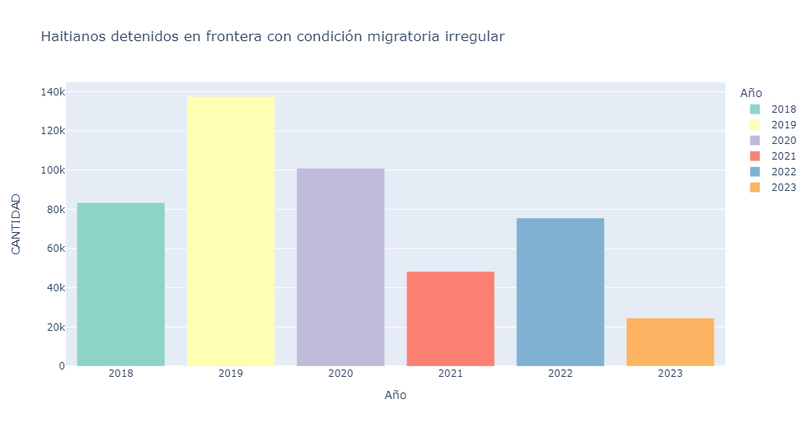
Graph 1
In fact, there have been years where more than 100 thousand people with irregular status have been captured at the border. This may be only a fraction when compared to those who manage to enter without being apprehended. But it is also the figure that Dominicans fear. Now, you have to take this with a grain of salt. The monthly figure appears below, and dates from almost eight thousand people detained monthly. The reality is that this figure corresponds to people who are detained, who probably try to cross the border again or even cross the border daily and are detained from time to time, but return home. This figure is an indicator of how much the authorities have dedicated in recent years to detaining irregular immigrants, but as we have seen, this does not mean that the number of immigrants is beginning to decrease. The truth is that, in a circular migratory movement, those detained at the border are a salute to the flag, because sooner or later they will cross the wall and eventually also return.
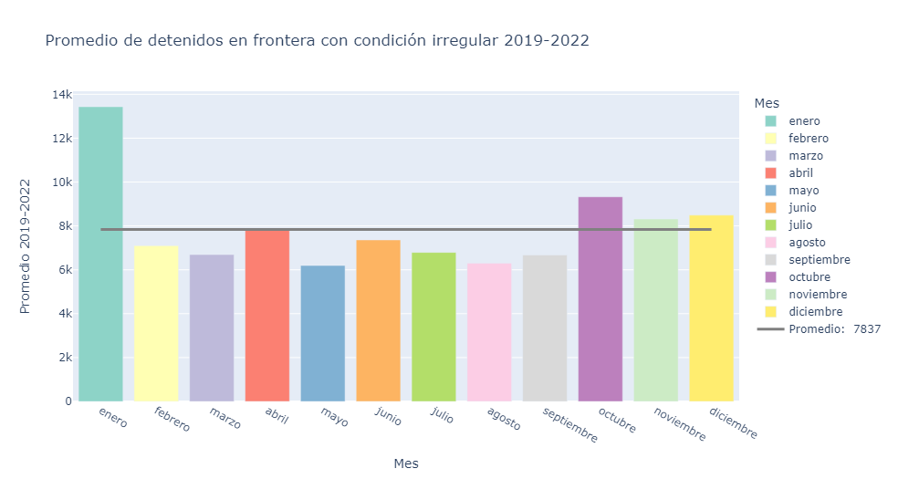
Figure 3
The largest number of detainees with irregular status at the border occur in January. This is most likely because immigrants return home for Christmas, and when they come back the flow increases. Immigration is circular, and it is common for Haitians to come and go, even after being deported. Therefore, those detained at the border with irregular status contain high figures, but this is most likely due to double counting, or the constant capture of people coming and going. So no further conclusions can be drawn.
In another instance, some foreigners in the country receive resident status and on some occasions can even be naturalized in the country if they prove any Dominican ancestry. The data published by the DGM includes naturalizations and residencies issued by nationality from 2018 to 2023. Among the aspects to highlight in this regard, Haiti is one of the countries that receives the most residences in these datasets. Among naturalizations, although they are relatively few, Venezuela occupies the first place, and Haiti is somewhat behind being in 7th place (when discounting the other category). The following charts describe naturalizations and residencies:
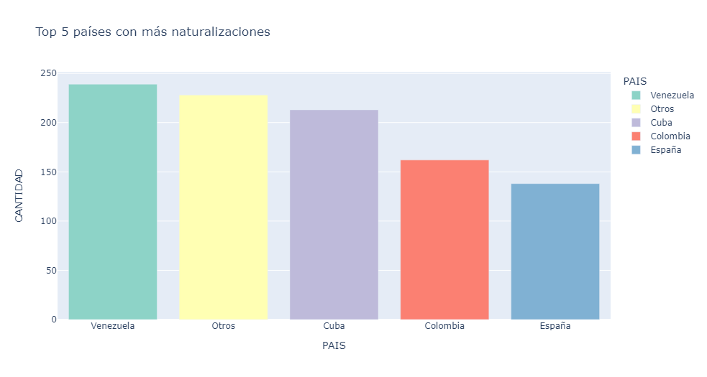
Figure 4
Graph 4 presents naturalizations. As already mentioned, Venezuela predominates, as it is a country that has had various flows over time and that still retains many ties. It is followed by Cuba, for the same reason and for its geographical proximity. And finally Colombia and Spain.
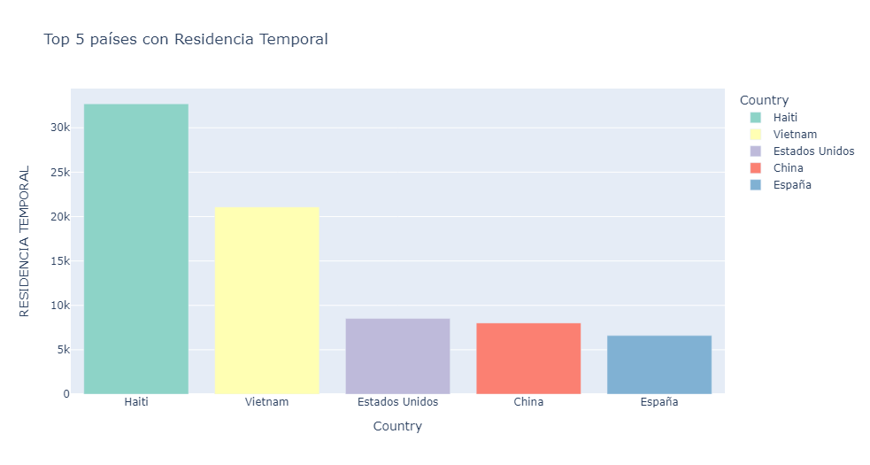
Figure 5
Figure 5 presents the top five nationalities of the people who were issued a temporary residence permit. In this one, the importance of Haiti is evident, which occupies the first place, then Vietnam, which has had a remarkable relevance, and is followed by the United States, China and Spain. Temporary residency is a status that must be renewed annually, and is issued primarily to workers and students. In the case of Haitians, many entered the country last century with temporary permits to work in the sugarcane industry under the bateyes modality. Modern Haitian immigration is rather focused on areas such as construction and labor that do not require high specialization.
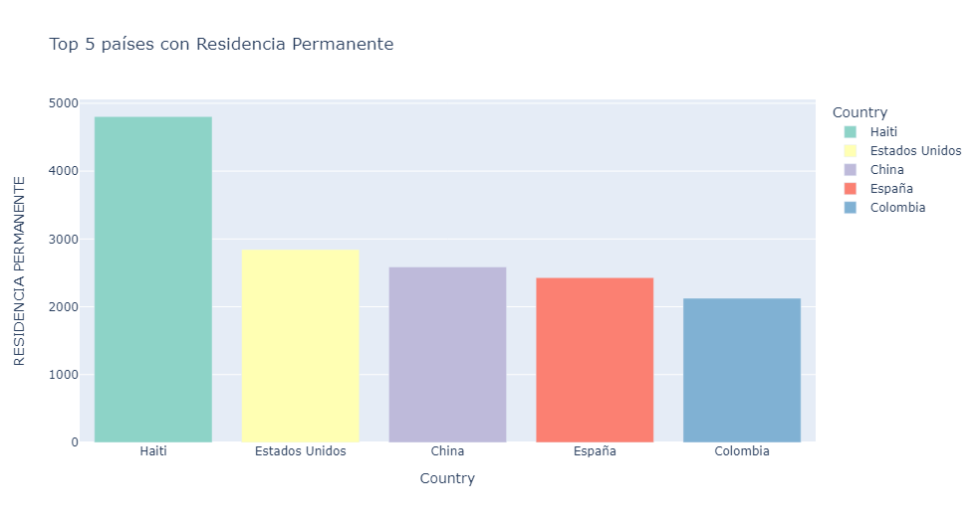
Figure 6
Graph 6 refers to the permanent residences by country of origin of the person receiving the benefit. Permanent residency is obtained after five years of renewing the temporary residency, and in this case it is also headed by Haitian nationals. Following it is the United States, then China, Spain and finally Colombia.
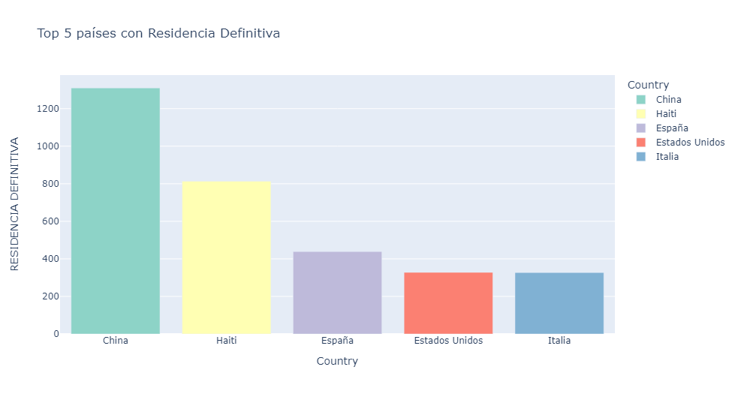
Figure 7
Finally, Graph 7 refers to the permanent residences issued by the beneficiary's country of origin. This residency is obtained after having resided regularly in the country for ten (10) years, and is extended as a residence permit for another ten (10) years. In this case, Chinese immigration stands out and is positioned in first place. Then, it is followed again by Haiti, Spain, the United States and finally Italy.
From all of the above, two things can be concluded regarding Haitian immigration in the Dominican Republic. The first is that due to the high arrival of Haitian nationals, they occupy the top positions in terms of residence permits. However, they are quite far behind when it comes to naturalizations. Now, and in a general way, understanding the size of immigration in the country, the limited issuance of permanent residencies and much more naturalizations is striking. Well, at least in the latter, in the selected period only 74 naturalizations have been issued to Haitian nationals, although the population is close to 500 thousand. This opens the question about the children of Dominicans and Haitians, who are usually reported as children of foreigners and do not necessarily receive the treatment of a Dominican. Likewise, the residences for Haitian nationals barely total 35 thousand, which does not represent even 10% of the Haitian population residing in the Dominican Republic, but it is close to the number of people who crossed the border from Haiti and have not returned.
As an addendum, one of the first ideas in this report was to report on the use of Dominican medical facilities by Haitian nationals who cross the border to receive service. In this sense, related information is limited to news sources, who cite that about 30% of births in the Dominican Republic correspond to Haitian mothers who cross the border to have their delivery attended. Public opinion on the Spanish-speaking side of the island, enraged by this figure, continues to reject the use of taxes in the care of foreigners. Although the news cites a report from the Ministry of Health, and its databases, in this report the verification of this data was not possible since the ministry's open data page was broken, and the report was not published. Therefore, and understanding the magnitude of the figure cited by the media, the general public is advised to verify sources and check the information obtained from primary sources. Moreover, without access to official sources, nothing can be concluded in this regard.

Perception and Arrests
In the Dominican Republic, it is almost evident that the opinion of Haitians tends to be negative. The negativity of the perception of the foreigner is directly related to the darkening of the skin, as reviewed in the report of the U.S. embassy regarding racial actions and profiling by immigration authorities. The evidence that can prove this claim is initially related to ethnographic data collected while living in Santo Domingo, listening to taxi drivers and friends mention how Haitians are ruining the country or that they are "bad" immigrants. This discursiveness is recurrent on social networks, and on platform X it abounds.
Xenophobic discourses have various origins and also their consequences. For this report, I will explore a possible configuration of such discursivity from government entities, in this case the presidential communiqués (available on the website). This does not imply that xenophobic discourse has an institutional origin, rather, the review will allow us to visualize the discourse that is generated from the presidency in relation to Haiti. But of course, being an official media with a neutral and formal language configuration, it is likely that the communiqués do not have predominantly negative tendencies.
On the second point, about the consequences, I ask myself a question: who do the Dominican authorities arrest? I will do it from the arrests to contrast the origins of the arrested and the arrest rates against the rates for Dominican nationals. This is because there are concerns about racial profiling by immigration authorities, and given the interaction of the authorities with the civilian population, it is possible that the profiling will also extend to the police. Therefore, I will check the arrests based on nationalities to see if there is indeed a relationship with the ethnic component, since, as we have already seen, foreigners in the Dominican Republic are mainly Haitians.
For the former, the analysis of presidential communiqués occurs because they are public and official data. I did not access presidential speeches, communiqués from other institutions, or local newspapers due to difficulties with information gathering and time limits. This exercise is simply to analyze the sentimentality of presidential communiqués that contain keywords related to Haiti. In this case, communiqués containing the words: Haiti, Haitian, Haitians, crisis, border and immigrant. Subsequently, a compilation of all the communications was made in a database that contained the information of titles, body of the text, date, labels and location. This database gathered 700 communications, starting from 2020 to date. To explore the communiqués, after eliminating some redundant words (such as president, proper names, minister, and conjunctions), the Graph 5 cloud was created.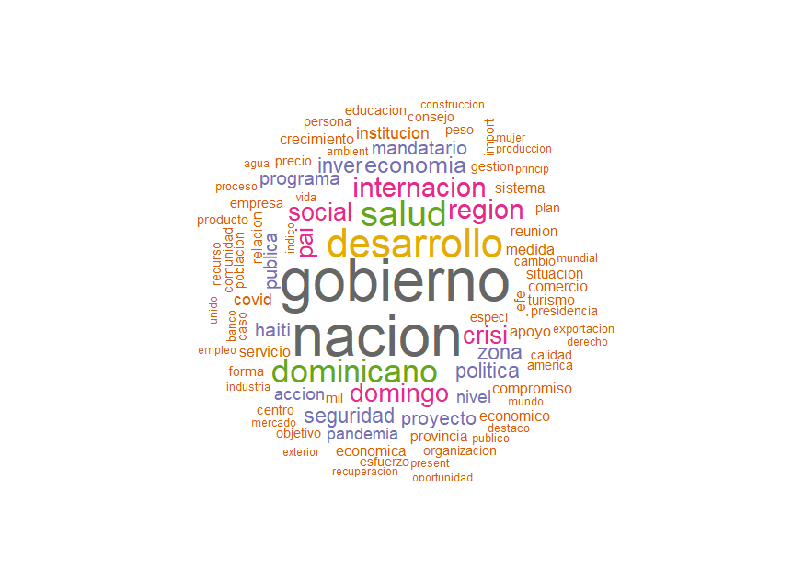
Figure 8
In this graph, it can be seen how the most used words (after the purge) are government and nation, followed by development, dominican and health. Here it is evident that the communiqués refer to the country's projects and the presidential agenda 2020-2024, since these words probably come from mentioning the development plan in the country, and the various social plans, for health and the region. It is followed by words such as crisis, which was one of the search criteria, Haiti, security, pandemic, politics, action and security. These make evident in the first place the search criteria used to search for the communiqués, but also the connection between security and the crisis, in addition to including the call to action or the work of the presidency to solve these problems. The other words are part of the dictionary that would be expected when dealing with presidential statements related to foreign policy and a neighboring country in crisis.
Subsequently, a latent topic analysis was developed. This means that with the use of a machine learning algorithm called Latent Dirichlet Allocation (LDA) (Blei, Ng & Jordan, 2003), which estimates the appearance of words together in relation to other words and which estimates a category immersed in the text or also called a topic. In other words, it is an algorithm that calculates the topics that are talked about in the texts that are entered based on the relationship that the groups of words have. This means that it will identify topics but its interpretation will depend on each user. For this particular case, I ran a metric analysis algorithm for the number of topics and their performance, so that the model can learn efficiently and produce a number of topics that allow conclusions to be reached. The following graph is a representation of the analysis: 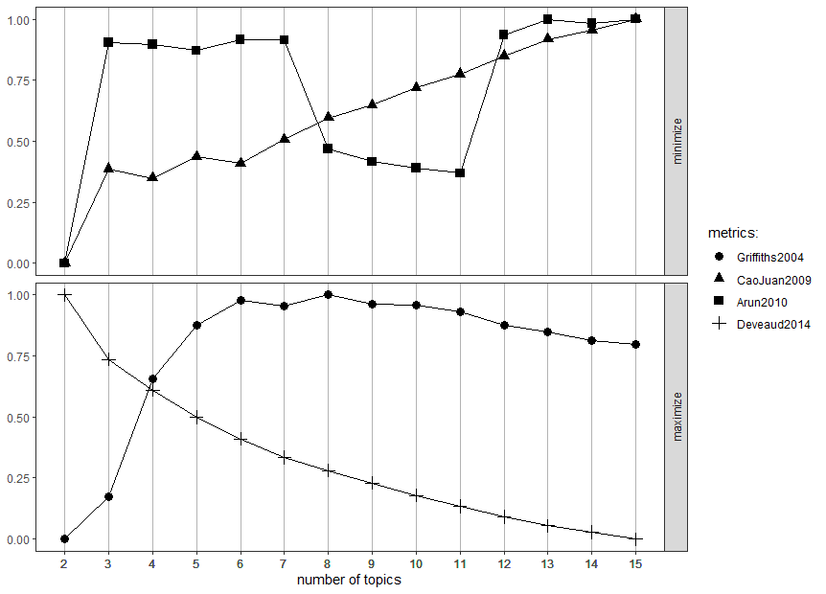
Figure 9
As you can see, the ideal number of topics is between six (6) and eight (8), but for reasons of practicality I decided to go along with Griffiths (2004) and stick to the six topics. When executing the topic analysis, the following representation appears, where each topic is a box and the frequency of each word is measured with the horizontal bar. The appearance and frequency of each word allows us to intuit the aspect of which the topic is concerned, and the name of the topic is chosen by the author. 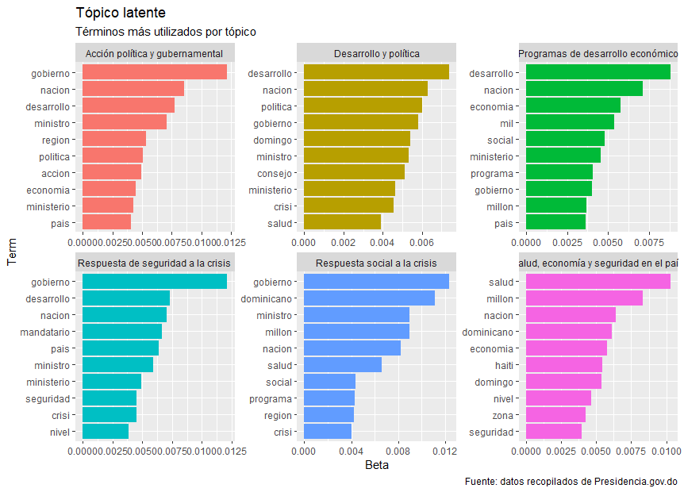
The following six topics appear: Government action and policy, development and politics, economic development programs, security response to the crisis, social response to the crisis and finally health, economy and security in the country. It is only in the sixth topic that the word Haiti frequently appears, and it occurs in conjunction with health, possibly due to the aforementioned hospital problem (which includes the arrival of immigrants to be treated in the Dominican Republic), along with the Dominican economy, nation, zone and security. At least this set of words, allows us to think that this topic talks about issues related to the neighboring country, where the most common topics include health, the economy and security. In this sense, it is pertinent to think that this latent cliché is evidence that the presidency is concerned or at least mentions Haiti in terms of the economy, security and health, but it also does so at the same time that it mentions the word Dominican, either as a mention of the government or as a mention of the people.
The topics Security Response to the Crisis and Social Response to the Crisis are two sides of a coin. Taking into account the temporality of the statements, these topics most likely refer to the covid-19 pandemic, although probably also to the crisis in the neighbouring country. With this, from the frequency of the words it can be deduced that the presidential communiqués speak of responding to the crisis by alluding to the president, the Dominican government and mentioning social programs for health and safety. And regarding the first three topics, they refer to the issues that are commonly addressed by the official communiqués of a government mentioning the development, budgets and programs carried out, but there is no reference here to immigration or the neighboring country.
Well, once you know the topics that are addressed in the 700 selected communiqués, the feelings that appear and the negativity or positivity of the sentences will be analyzed. For this section, a semantic analysis is carried out based on the NRC lexicon in Spanish (Mohammad & Turney, 2010) which is a model where a large number of words are classified with a positive, negative or neutral charge and a related feeling is also assigned. For this particular case, the feelings anger (anger), fear (fear), expectation (anticipation), trust (trust), surprise (surprise), tristeza (sadness) (joy) (joy) and disgust (disgust) appear. In this way, the model classified the text as follows: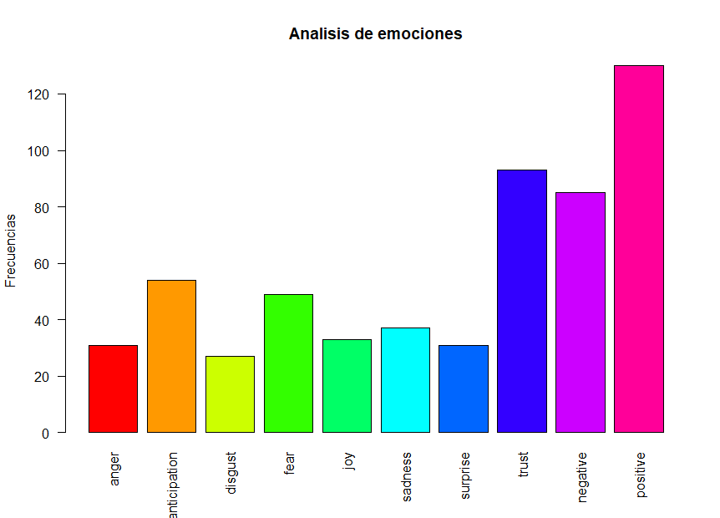
Figure 10
Figure 10 indicates that the predominant sentiment is confidence. And it is not surprising, since the presidential communiqués should partly express confidence to citizens about the activities that the government is carrying out. It is followed by expectation and fear, expectation being a neutral feeling, since it is simply the classification of words that leave some degree of uncertainty or a reason why some result is expected regardless of whether it is good or bad. While fear is a predominantly negative feeling, indicating that the communiqués transmit fear to some extent to their audience. Sadness follows in fourth place, and is almost on a level with the other feelings. At this point, the remaining feelings are not entirely conclusive.
Regarding positivity, it is striking that there is so much negativity in the text. And it is that, as these are official statements, a very low negativity would be expected. Although positive sentiment predominates, it stands at around 60% of the total. Therefore, it is pertinent to conclude that there is significant negativity when dealing with issues involving the neighboring country, even in the case of official statements. This does not accurately indicate the existence of some type of xenophobic discourse or the promotion of anti-Haitian discourse, but it is evidence that observes how the official communication of the presidency when referring to matters related to Haiti contains an important negative measure, of confidence (which can be related to nationalism), expectation, fear and sadness.
To address the second point, the concern about racial profiling stems from complaints that indicate profiling in border areas and even more so, in tourist sites. Apparently, the agents of the General Directorate of Migration (DGM) use criteria such as skin tone to decide to capture an individual and send him, without further mediation, to the Haina Detention Center. For example, the U.S. Embassy last year issued the following: "This message is to warn U.S. citizens that recent travelers to the Dominican Republic have reported delays, detentions, and intense interrogations at ports of entry and in other encounters with official immigration officials based on their skin color. Reports of disparate treatment of U.S. citizens by Dominican authorities are a matter of current concern to the U.S. Embassy" (U.S. Embassy in the Dominican Republic, 2022). With this, it is more than evident the existence of a persistent problem with arbitrary detentions by the authorities based on skin color. The situation can be daily, and in daily life it is common in the Dominican Republic to call Afro-descendants Haitian, finally confusing ethnicity with nationality.
In this way, rather than accessing data on deportees or captured by the DGM who are predominantly Haitian, an analysis of the database on people arrested by the national police from January 2017 to July 2023 was carried out. Where arrests are classified according to age groups, sex, and whether the arrestee is a national or foreigner. By the way the database is configured, each attribute of the arrest is divided in terms of the total value of arrests for the period, indicating the quarter and year of each of the data. This limits the classification of arrests, since it does not compose the data in a relational way, separating, for example, the sex of national and foreign arrestees. These data were indeed calculated, but the margin of error is high, since the estimates are derived from the proportions. Even so, to visualize at least the gender component in the distribution of arrests, the following graph was prepared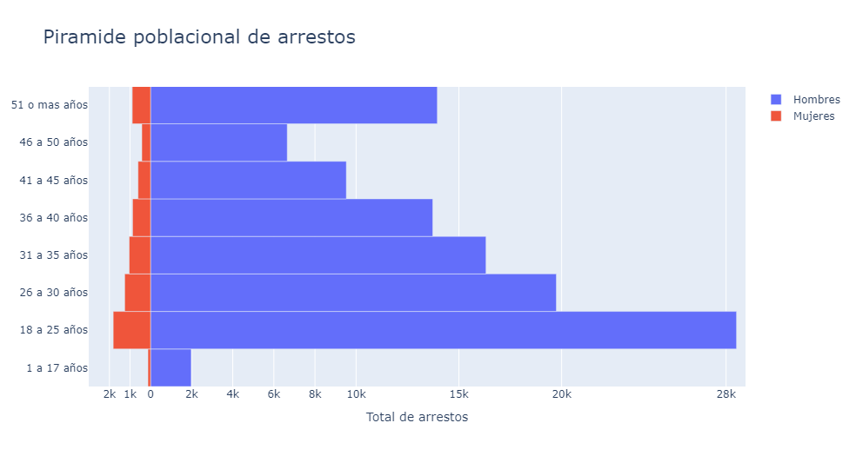
Figure 11
As is the trend around the world, arrests are predominantly of men. However, these are also concentrated in young people from 18 to 25 years old, and down to 50 years old where there is a rise in arrests, probably due to the breadth of the age section. These data are an estimate, and are expected in any global trend, since young men are the ones who are most involved in criminal acts. These data would probably reveal different trends if they had been collected with individual values by age, nationality and sex, but at least to understand the distribution this approximate works.
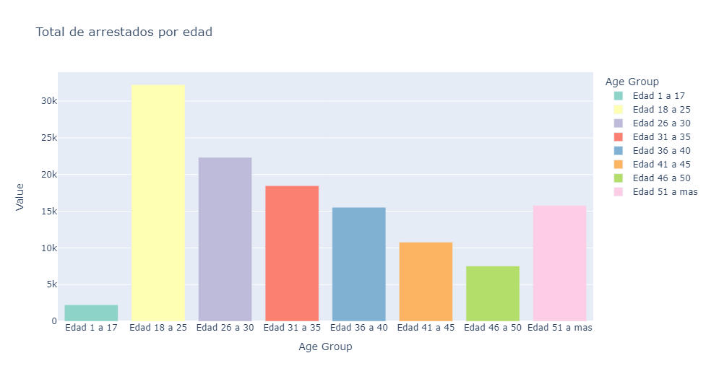
Figure 12
Figure 12 is the total age distribution of arrests, and is more or less similar to the previous one. Arrests predominate among young people, with a minimum of minors.
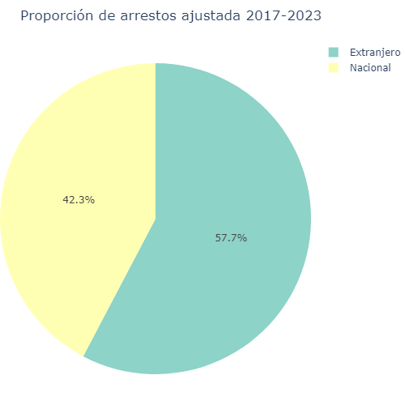
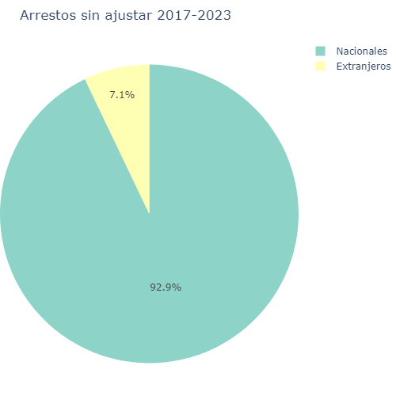
To the above must be added another component to understand the matter more realistically. In principle, the answer to the question: who do the Dominican authorities arrest? In absolute terms it is evident, the largest number of arrests are of Dominicans. But, within this figure you must understand the magnitude of each number. Although of the total number of arrests, those corresponding to foreigners are only 7.1% (as shown in Graph 10) of the total, the foreign population is only 5.6% according to the ENI (2017). To correct the magnitude, the number of arrests of foreigners must be multiplied by the number of times the foreign population fits in the Dominican Republic, equivalent to just over 17. Once the magnitude has been corrected, the figure is as indicated in the following graphs:
Figure 13
Figure 14

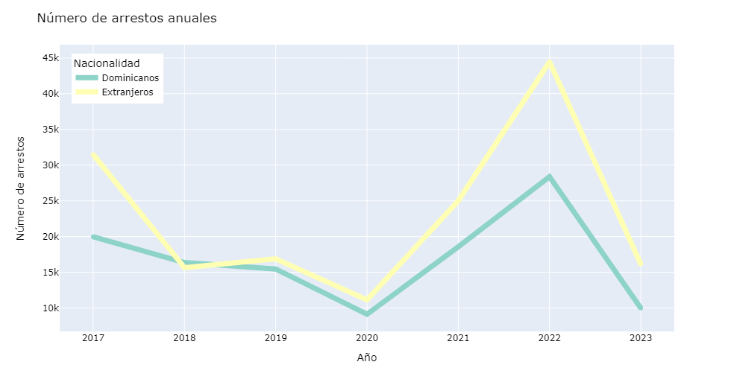
Thus, with the adjustment it is much more evident that the probability of being arrested if you are a foreigner increases. In this case, it would not be possible to calculate exactly what the figure looks like for Haitians due to the absence of the attribute in the database, but an estimate would be that at least 90% of the arrests of foreigners, only by proportion, must be of Haitian nationals. This figure changes with each year, and depending on each year, arrests of foreigners become more prominent , as can be seen in the following graph
Figure 15
Depending on the period, it varies who was most likely to be arrested. By 2022, a foreigner was almost twice as likely to be arrested compared to a national. While, in 2018, the figure was almost 50% with a slight propensity towards nationals. Now, for the historical, foreigners have had a slightly higher propensity to be arrested than nationals, which would confirm the intuition that foreigners are usually arrested more often when the size of each population is understood. The database does not specify the nationality of those arrested, however, given the vast majority of Haitians residing in the Dominican Republic, one can get the idea that the racial profiling denounced by the U.S. Embassy in immigration authorities could also exist in the national police.
The conclusion is that it is very likely that there is racial profiling, if not foreigners by the Dominican authorities. In this country it is common to see migration trucks full of immigrants, and the complaints allow us to get the idea that there is indeed racial profiling for it. Now, arrest statistics suggest more or less the same thing, as foreigners are usually Haitians and the total for the last few years indicates that there is a propensity to arrest foreigners. It is important to note that this figure corresponds exclusively to arrests, not prosecutions, so it is a good indicator of how authorities tend to arrest foreigners. And finally, the gap in arrests towards foreigners increases considerably from 2020, when the Abinader government takes over, who distinguishes himself by promoting strong anti-immigrant policies (even building the wall), and this is also evident in the arrest statistics.
Conclusions
As we have seen, the history of the Dominican Republic has really been built from the opposition with the neighboring country that invaded them in 1802 and on several other occasions. The memory of this dark instance in history makes the Dominican exist in opposition to the Haitian, since it is not only hatred or fear, but the construction of an otherness that resorts to the classification of savage, uneducated, or the difference so abysmal that it has no remedy. When you ask, you will hear answers such as that the Haitian is too different from the Dominican, his language, his culture, his religion, and this difference, although true, causes to some extent hatred or perhaps displeasure. The Dominican apparently cannot coexist with the Haitian, and to that extent identity is based on the aspects that separate them.
Migration from the neighboring country has always been and will continue in perpetuity. Whether the number of people increases more or less, the truth is that at some point solutions will have to be found that allow the coexistence of the transit of people, their protection, or the implementation of international policies that generate better conditions for the western country. Meanwhile, the circularity of this immigration complicates the situation, and the efforts of the authorities are hopelessly fruitless. In this regard, the racial profiling by DGM agents is worrying, and to some extent the existence of negative feelings is proven from official communications. The evidence surpasses linguistic analysis, which in itself shows a slight inclination towards messages of fear and sadness, and instead the arrests result in evidence that proves the authorities' inclination towards capturing people of African descent or of foreign origin.
Finally, these processed data originate from rather concise data sources, since the databases omit details that could be relevant for more in-depth research or that seek to generate lasting solutions for public policies. The example of arrests is one, and given the lack of an individual count, a broad characterization of individuals or the generation of a database that collects a greater diversity of attributes, attempts to make more complex analyses are futile and based on mere estimates. That said, all the data sources used need to include raw data and more extensive compilations on the characteristics of the census takers. Finally, the only generalized attributes were sex and nationality, which indicates the country's concern about the migration issue; but it remains limited for other analyses that could include more ethnic, age, social class or even geographic location variables.

References
Saif Mohammad and Peter Turney. "Emotions Evoked by Common Words and Phrases: Using Mechanical Turk to Create an Emotion Lexicon." In Proceedings of the NAACL-HLT 2010 Workshop on Computational Approaches to Analysis and Generation of Emotion in Text, June 2010, LA, California. See: http://saifmohammad.com/WebPages/lexicons.html
Blei, David M.; Ng, Andrew Y.; Jordan, Michael I (January 2003). "Latent Dirichlet allocation". In Lafferty, John, ed. Journal of Machine Learning Research 3 (4–5): pp. 993–1022. doi:10.1162/jmlr.2003.3.4-5.993. Archived from the original on May 1, 2012. Retrieved September 18, 2012.
Polanco, V., Castillo, E., Chalas, N., Reyes, R. (2017) Migrations on the Haiti – Dominican Republic Border: A Descriptive Look at a Shared Reality in Migratory Movements on the Ibero-American Borders. Guatemala City, Guatemala: Editorial Kamar
Páez, W. (2006) The Dominican-Haitian border: historical perspective and present. Santo Domingo. General Archive of the Nation. Page 38
Jáuregui, C. A. (2009). The "Negro Comegente": Terror, colonialism and ethno-politics. Afro-Hispanic Review, 28(1), 45–79. http://www.jstor.org/stable/41350895
Franco, F. J. (2009). History of the Dominican People (6th ed.). Dominican Publishing Society.
Diario Libre, March 6, 2010. Dominican Demography (1795-1844). Online article. Accessed July 26, 2023. Link: https://www.diariolibre.com/opinion/lecturas/demografa-dominicana-1795-1844-NJDL236812
Zizek, S. (2011). The harassment of fantasies. Akal.

